

SYMBIOSIS INSTITUE OF TECHNOLOGY
(Established under section 3 of the UGC Act 1956) Re-accredited by NAAC with “A” Grade

Name : Aniruddha Pratap Singh
Year: AY 25-29
PRN: 25070122247
Semester: 3

ASSIGNMENT No: 15
TITLE: Write a Java program to demonstrate exception handling using finally, throw, and throws.
Problem Statement :
Write a Java program to demonstrate exception handling using finally, throw, and throws.
The finally block always executes regardless of whether an exception occurs, making it suitable for resource cleanup. The throw keyword explicitly generates an exception, while throws declares exceptions that a method may pass to its caller. These mechanisms improve structured error handling and application stability.

Program :
import java.io.IOException; public class FinallyThrow {
// Method using throws
static void checkAge(int age) throws IOException {

if (age <= 18) {
// Using throw
throw new IOException("Age must be 18 or above.");
}

System.out.println("Eligible for voting.");

}

public static void main(String[] args) { try {
checkAge(15);

} catch (IOException e)
{

System.out.println("Exception: " + e.getMessage());

} finally
{

System.out.println("Verification process completed.");

}

}

Output :
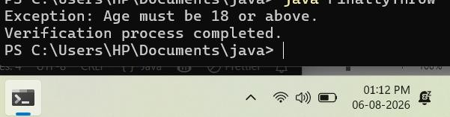

Exercise 1: Create a Login program that throws an

exception for invalid password and uses finally block Program :
import java.util.Scanner; public class LoginProgram {
public static void main(String[] args) { Scanner sc = new Scanner(System.in); String correctPassword = "java123"; try {
System.out.println("================================");
System.out.println(" LOGIN SYSTEM"); System.out.println("================================");

System.out.print("Enter Password: "); String password = sc.nextLine();
if (!password.equals(correctPassword)) {
throw new Exception("Invalid password entered.");
}

System.out.println("Login Successful!"); System.out.println("Welcome to the system.");
} catch (Exception e) { System.out.println("Login Failed!");
System.out.println("Reason: " + e.getMessage());
System.out.println("Please enter the correct password.");
} finally {
System.out.println(" ");
System.out.println("Login verification process completed."); System.out.println("Thank you for using the system."); System.out.println(" ");

}

sc.close();
}
}

Output:
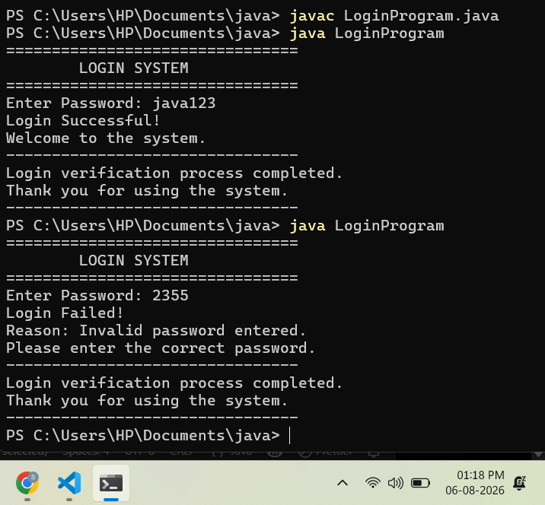

Exercise 2. Create an ATM PIN Verification program that throws an exception for an invalid PIN entered by the user and uses a finally block to display a message indicating that the verification process has completed.
Source code:
import java.util.Scanner;
public class ATMVerification {

public static void main(String[] args) { Scanner sc = new Scanner(System.in); int correctPin = 1234;
try {
System.out.println("================================");
System.out.println(" ATM PIN VERIFICATION"); System.out.println("================================");

System.out.print("Enter your ATM PIN: "); int pin = sc.nextInt();
if (pin != correctPin) {
throw new Exception("Invalid ATM PIN entered.");
}

System.out.println("PIN verified successfully."); System.out.println("You can now access your account.");

} catch (Exception e) {
System.out.println("Verification Failed!"); System.out.println("Reason: " + e.getMessage()); System.out.println("Please enter the correct PIN.");

} finally {
System.out.println(" ");
System.out.println("PIN verification process completed."); System.out.println("Thank you for using the ATM."); System.out.println(" ");

}

sc.close();
}
}

Output:
